**Project Summary**

Our project name is the robot project. And our purpose of the project is to let robot to shut down the red beacon, and move the green beacon one across the line.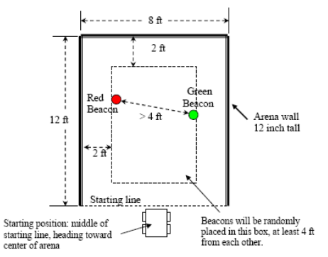

First, we use the VEX robotic kit to build the physics part of robot. We total used three Motor, two for wheels and one for “arms”. The purpose of arm is to shut down the red beacon. And move the green beacon across the line. We construct the Infrared Receiver(IR) Board in front of the robot to read the intensity of light reaching the detectors. Also, we used four bumper to sense a “running against the wall” condition.

Second, we used the EasyC software to program. The core part is the VEX controller. We connect the VEX controller and computer. Later, we download the code from computer to VEX controller to achieve our task.

In this project, we have learned how to cooperator with others. We learned how to design the Mechanical part of a robot and how to program the code of a robot.

**Design Performance**:

The purpose of our project is to shut down the red beacon and move the green beacon across the line. And we already achieve all the tasks. We total spend the 26.11 seconds to finish the task. And we also design one bumper to start and stop the whole program. We add some code to hit function to hit the red beacon more than once if it is not shut down. Tim was really work hard in this part.

However, we still have a little problem in performance. Our robot is hard to go straight to each beacon. We come up a few guesses about this problem. Our motors may different, therefore, they cannot move exactly same.

Anyway. We performance the all task successfully.